**A Closed-Loop System for Treatment and Prevention of Bruxism**

**Problem Statement**

Bruxism, or involuntary teeth grinding, leads to dental damage, discomfort, and reduced quality of life, with current treatments limited by reactive and subjective approaches.

**Solution Overview**

There is a critical need to accurately detect bruxism episodes in real-time, provide personalized insights, and empower users to take proactive steps to manage the condition effectively. Utilizes EMG sensors on the jaw to detect bruxism, triggering vibrations for muscle relaxation and offering an app for management of grinding habits.

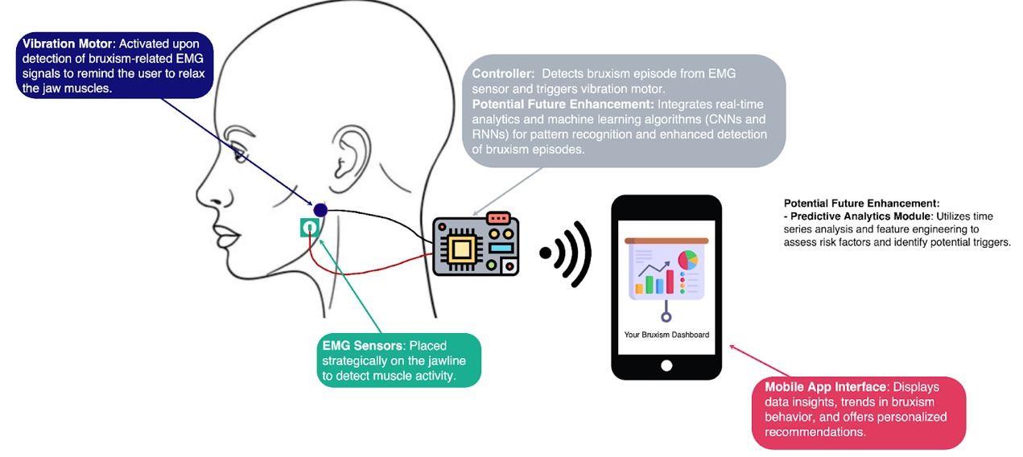

**Target Users:**

The primary users are individuals suffering from bruxism who need a proactive and effective management system to mitigate symptoms and prevent dental complications. They would use this device to monitor and control their bruxism, improve dental health, and enhance quality of life.

**Potential Impact:**

- Improved dental health and reduced treatment costs.

- Alleviation of pain and discomfort, enhancing quality of life.

- Behavioral modification through self-awareness and proactive habits.

- Stress reduction by identifying and managing triggers.

**Questions/Concerns about the project:**

* How will the system ensure accurate and reliable detection of bruxism episodes in various sleep conditions?
* What measures will be taken to ensure user comfort and prevent irritation from the device during prolonged use?